**Case Study: Impact of Adding Shunt Capacitors to Regulate Reactive Power in a High Voltage Transmission System.**

John Mwangi Muchori*, Undergraduate-Bsc Deg in EEE,*

*Dedan Kimathi University of Technology*

*October 9, 2024*

**Software: Power world simulator**

**Abstract**

This simulation-based case study explores the effects of adding shunt capacitors in parallel to the load at various buses of a transmission system from results obtained from simulation from power word simulator which is designed for analyzing, visualizing, and simulating power systems, particularly for transmission and distribution networks .By compensating for reactive power, shunt capacitors improve system performance in terms of efficiency, line utility, power factor, voltage regulation, and line carrying capacity. This paper analyzes these aspects by focusing on technical parameters such as voltage stability, reactive power flow, and system reliability.

**Introduction**

In modern power systems, reactive power management is essential for maintaining system stability, reducing losses, and improving voltage regulation. Shunt capacitors, commonly employed for this purpose, provide reactive power compensation by generating reactive power locally at load centers, thereby alleviating the burden on transmission lines and generators. With loads in the system drawing both real and reactive power, unregulated reactive power flow leads to voltage instability, poor power factor, and inefficiencies. This paper investigates the effect of adding shunt capacitors to the loads at critical buses, analyzing their influence on system performance and the associated technical benefits.

**Effects of Adding a Shunt Capacitor to the Buses in A High Voltage Power transmission System**

**Line Carrying Capacity**

The addition of shunt capacitors also increases the line’s capacity to carry real power by reducing the reactive power demand. Transmission lines are rated based on their ability to carry apparent powe , which consists of both real (MW) and reactive (MVAR) components. By minimizing the reactive power flowing through the lines, shunt capacitors free up more capacity for real power transfer. From *fig 2,* it is observed the after adding the shunt capacitors, the line between bus 8 and bus 9 is relieved .The 82 % in *fig 1* for the line, shows that the it is already overloaded, adding the reactive power compensators (shunt capacitors ) relieves the line and thus improving its capability to carry power .If we were to improve the line capacity of the line connecting bus 5 and bus 8, we will be required maybe to connect a shunt capacitor at bus 5 of a higher MVAR reading but as per the calculations. In the case of Bus 12, adding a 150 MVAR shunt capacitor would allow the transmission line to carry more real power, thus enhancing the overall load-handling capacity of the system and preventing overloading.

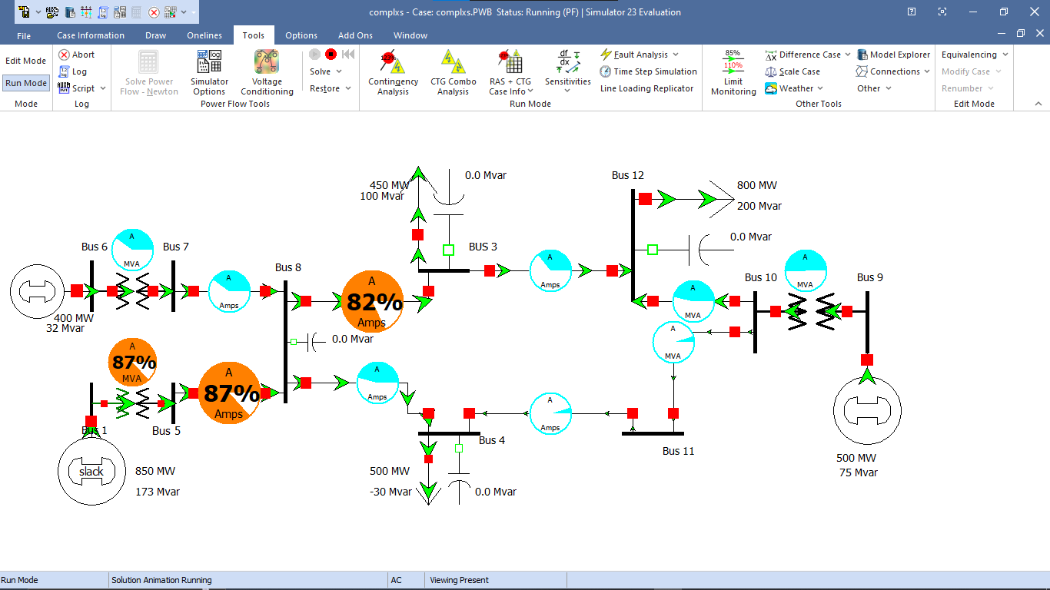

Figure 1.Before adding the shunt Capacitors

**Efficiency**

As seen from the simulation (before switching the shunt capacitors) the overall reactive power across the system is quite high.  
By compensating for reactive power locally, shunt capacitors reduce the reactive power burden on transmission lines and generators, as seen after switching on the shunt capacitors. This lowers the overall current flow in the system, thereby decreasing losses in conductors and transformers. The improved voltage profile also reduces the need for over-excitation of generators, which in turn enhances their efficiency. In this case, buses with high reactive power demand, such as Bus 12 (800MW, 200 MVAR load), would experience a significant improvement in operational efficiency as the transmission system carries less reactive power over long distances.

**Line Utility**

Line utility improves with the addition of shunt capacitors, as the capacitors supply a portion of the reactive power locally. As observed (*fig2*.) , this significantly reduces the total apparent power that must be carried by transmission lines. For instance, on Bus 12, where 200 MVAR of reactive power is required which is quite high, introducing the shunt capacitor parallel to that load at the bus will reduce the apparent power by lowering the reactive power demand. In other words the shunt capacitor compensates for the reactive power drawn by the Load from the systems. Actually the simulation shows some relief on the system. As a result, the line has more capacity to carry real power, making better use of the transmission infrastructure. This reduces congestion and allows the line to accommodate additional loads or generators.

**Power Factor**

A key benefit of adding shunt capacitors is the improvement in power factor, which is a measure of how effectively electrical power is converted into useful work. By locally supplying reactive power, shunt capacitors reduce the total reactive power drawn from the system, thus improving the power factor at the bus where they are installed. For example, at Bus 3, with a load of 450 MW and 100 MVAR, adding a 100 MVAR capacitor elevates the power factor from a lagging value of around 0.97 closer to unity. This enhancement in power factor leads to better voltage profiles and reduces the system’s total demand for reactive power.

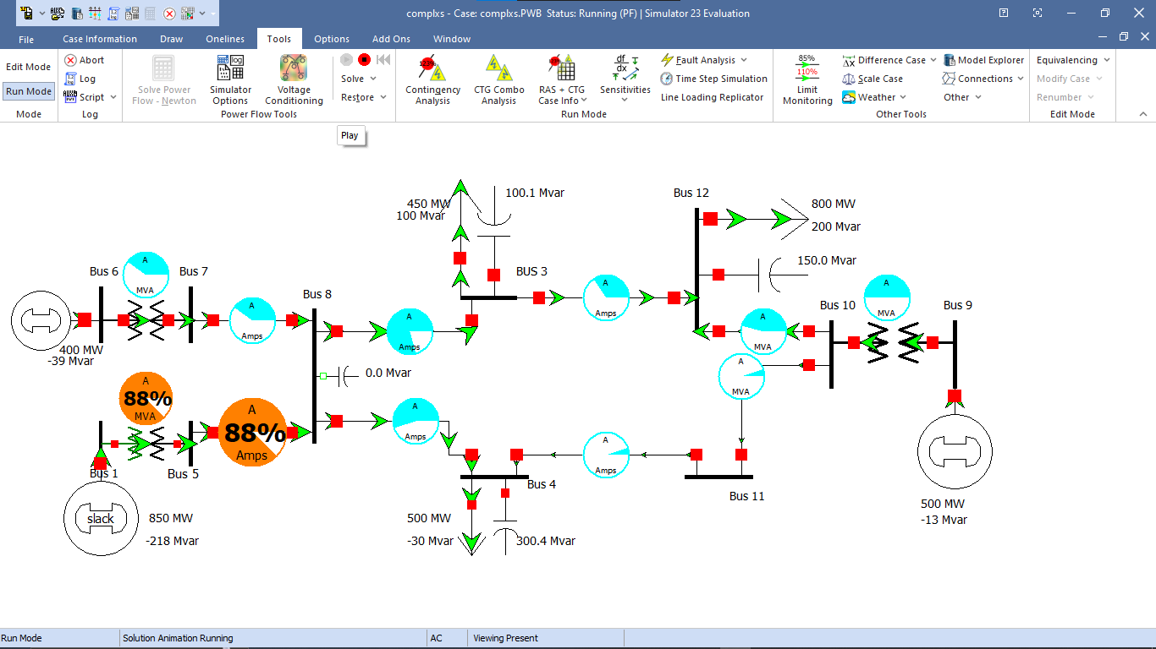

Figure 2.After adding shunt capacitors to the system

**Voltage Regulation**

Shunt capacitors enhance voltage regulation by maintaining a stable voltage profile across the system, especially at buses experiencing high reactive power demand. Capacitors supply reactive power locally, reducing voltage drops that occur due to inductive loads. Improved voltage regulation is particularly important in systems with long transmission lines where voltage can vary significantly. In this system, adding a shunt capacitor to Bus 12 would reduce voltage deviations and maintain the bus voltage near its nominal value of 138 kV, thus preventing under voltage conditions and enhancing the reliability of sensitive loads.

**Change in Reactive Power Flow**

Shunt capacitors significantly reduce the amount of reactive power that needs to be supplied by the generators. For instance, at Bus 12, which has a reactive power demand of 200 MVAR, introducing a shunt capacitor of 150 MVAR will reduce the net reactive power demand to just 50 MVAR. This reduction in reactive power flow minimizes the stress on transmission lines and decreases generator reactive power output, allowing generators to focus more on supplying real power. The overall effect is a more balanced and efficient power system with improved voltage stability and reduced system losses.

**Conclusion**

Adding shunt capacitors in parallel to the loads at critical buses in a transmission system can significantly improve performance by reducing reactive power demand, enhancing efficiency, improving voltage regulation, and increasing the line's real power carrying capacity.

These improvements make shunt capacitors an essential tool in modern power systems for ensuring stable and efficient operations.

REFERENCES

(SpringerLink)<https://link.springer.com/article/10.1007/s00202-022-01542-3>

(1Pratibha Bhor, 2018, p. 312)